**India maintains 40th position in Global Innovation Index 2023**

India retained the 40th position on the list of the most innovative economies in 2023 according to the World Intellectual Property Organization’s (WIPO) Global Innovation Index (GII), that ranks 135 economies across the world.

Commenting on India's accomplishment, the country's nodal agency NITI Aayog said in a press statement, "India has been on a rising trajectory, over the past several years in the Global Innovation Index (GII), from a rank of 81 in 2015 to 40 in 2023. Innovation has been at the forefront of our battle against the unprecedented crisis created by the pandemic and will be pivotal in driving the country’s resilience."

The top ten countries featured in the list include Switzerland, Sweden, the USA, the United Kingdom, Singapore, Finland, Netherlands, Germany, Denmark, and the Republic of Korea.

<https://x.com/WIPO/status/1706935370951147698?s=20>

<https://x.com/WIPO/status/1707273935350562966?s=20>

"A total of 21 economies outperformed on innovation as expected relative to their level of development, the majority located in Sub-Saharan Africa and South East Asia, East Asia, and Oceania. India, the Republic of Moldova and Viet Nam are each innovation overperformers for 13 years in a row," WIPO said. The director general of the organization, Daren Tang said that a group of emerging economies are consistently climbing the GII ranks.

The findings conclude that scientific publications, research and development (R&D), and the number of venture capital (VC) deals and patents continued to increase to higher-than-ever levels. It observed that the technology adoption is developing positively even though penetration for some technologies, such as electric vehicles and cancer treatment, remains low.

Further, the recent surge of artificial intelligence and the information and computing technology (ICT) hardware sectors saw graphic card and chipmakers in the lead with the most notable R&D growth in 2022. Meanwhile, other sectors which cut back R&D spending during the pandemic, such as automobiles and travel and leisure, invested strongly again in 2022.



Representative image (Image: iStock)

Switzerland tops the list followed by Sweden, United States, United Kingdom, Singapore, Finland, Netherlands, Germany, Denmark, and the Republic of Korea.

**M S Swaminathan, Father of India’s Green Revolution passes away**

Indian agricultural scientist M S Swaminathan passed away on September 28, at his residence in Chennai, at the age of 98. The founder of MS Swaminathan Research Foundation (MSSRF) is survived by his three daughters: Dr Soumya Swaminathan, chairperson of MSSRF; Dr Madhura Swaminathan, professor at the Indian Statistical Institute; and Nitya Swaminathan former lecturer at the University of East Anglia.

Expressing grief over the demise, Prime Minister Narendra Modi posted on social media, "At a very critical period in our nation’s history, his groundbreaking work in agriculture transformed the lives of millions and ensured food security for our nation."

<https://x.com/narendramodi/status/1707297521251598681?s=20>

Swaminathan has been recognised by TIME magazine as one of the twenty most influential Asians of the 20th century. The father of the green revolution has won many accolades in recognition of his contribution, including the Ramon Magsaysay Award for Community Leadership in 1971, the Albert Einstein World Science Award in 1986, the First World Food Prize in 1987, and Volvo, Tyler and UNEP Sasakawa Prize for Environment, among others.

Swaminathan also received the prestigious Padma Shri (1967), Padma Bhushan (1972) and Padma Vibushan (1989). He was a fellow of many leading scientific academies of India and the world, including the Royal Society of London and the US National Academy of Sciences. He has received 84 honorary doctorate degrees from universities around the world.

Brn in Kumbakonam, India, on August 7, 1925. In the 1950s, Swaminathan explained and analyzed the origin and evolutionary process of potato in the 1950s. Later, he also researched the cytogenetics of hexaploid wheat. The varieties of wheat and rice developed by Swaminathan and Nobel Peace Prize recipient Norman Borlaug were foundational to the green revolution.

He had spent 15 months in the US where he accepted a post-doctoral research associateship at the University of Wisconsin, Laboratory of Genetics to help set up a USDA potato research station.

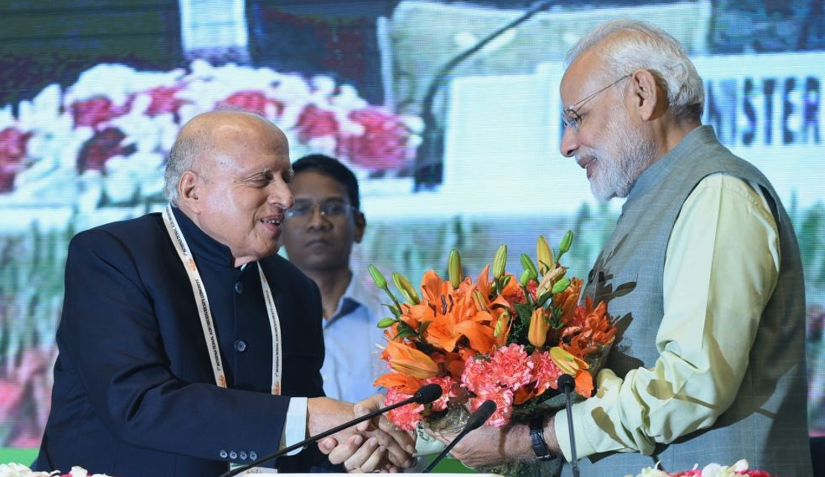

Indian scientist M S Swaminathan (Left) and Prime Minister Narendra Modi (right) (Image: X/@narendramodi)

Swaminathan has received 84 honorary doctorate degrees from universities around the world.